Create DAX calculations in semantic models
In this lab, you’ll create calculated tables, calculated columns, and simple measures by using Data Analysis Expressions (DAX).
In this lab, you learn how to:
- Create calculated tables.
- Create calculated columns.
- Create measures.
Download and Open Day2\Lab1\Lab 1 Starter-Sales Analysis.pbix file
Create the Salesperson calculated table
- In Power BI Desktop, in Report view, on the Modeling ribbon, from inside the Calculations group, select New Table.
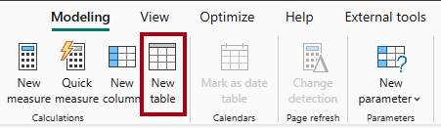
- In the formula bar (which opens directly beneath the ribbon when you create or edit calculations), type Salesperson =, press Shift+Enter, type 'Salesperson (Performance)', and then press Enter.
>> Salesperson table definition
==================================================
Salesperson = 'Salesperson (Performance)'
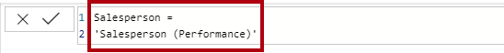
- In the Data pane, notice that the icon for the new table has an additional calculator in front of it (denoting a calculated table).
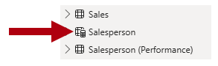
- Switch to Model view, and notice that the Salesperson table is available.
- Create a relationship from the Salesperson | EmployeeKey column to the Sales | EmployeeKey column.
- Right-click the inactive relationship (dotted line) between the Salesperson (Performance) and Sales tables, and then select Delete. When prompted to confirm the deletion, select Yes.
- In the Salesperson table, multi-select the following columns, and then hide them (set the Is Hidden property to Yes):
  - EmployeeID
  - EmployeeKey
  - UPN
- In the model diagram, select the Salesperson table.
- In the Properties pane, in the Description box, enter: Salesperson related to sales
- For the Salesperson (Performance) table, set the description to: Salesperson related to region(s)

Create the Date table
In this task, you’ll create the Date table.
- Switch to Table view. On the Home ribbon tab, from inside the Calculations group, select New Table.
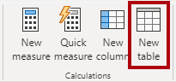
- In the formula bar, enter the following DAX:
code
Date = CALENDARAUTO(6)
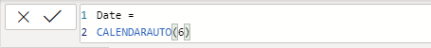

- Notice the column of date values which might be formatted using US regional settings (that is, mm/dd/yyyy).
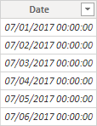
- At the bottom-left corner, in the status bar, notice the table statistics, confirming that 1826 rows of data have been generated, which represents five full years’ data.

Create calculated columns
- On the Table Tools contextual ribbon, from inside the Calculations group, select New Column.
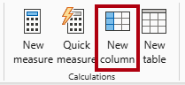
- In the formula bar, type the following (or copy from the snippets file), and then press Enter:
Year = "FY" & YEAR('Date'[Date]) + IF(MONTH('Date'[Date]) > 6, 1)
- Use the snippets file definitions to create the following two calculated columns for the Date table:
  - Quarter
  - Month
- Verify the new columns have been added.
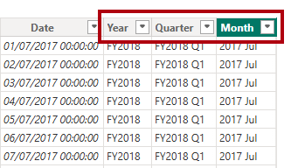
- To validate the calculations, switch to Report view.
- To create a new report page, select the plus icon next to Page 1.
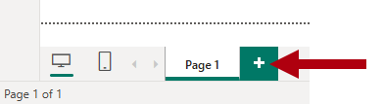
- To add a matrix visual to the new report page, in the Visualizations pane, select the matrix visual type.
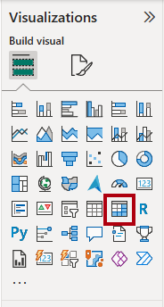
- In the Data pane, from inside the Date table, drag the Year field into the Rows well.
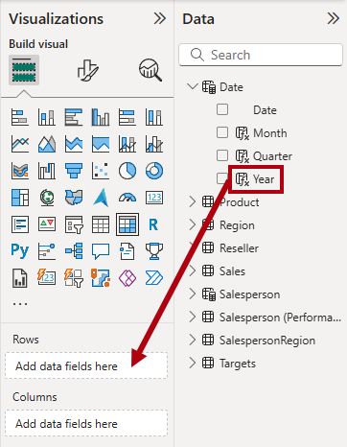
- Drag the Month field into the Rows well, directly beneath the Year field.
- At the top-right of the matrix visual (or bottom, depending on the location of the visual), select the forked-double arrow icon (which will expand all years down one level).
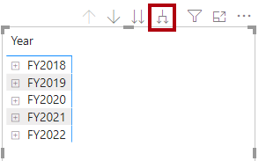
- Notice that the years expand to months, and that the months are sorted alphabetically rather than chronologically.
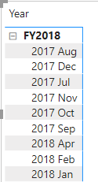
- To customize the Month field sort order, switch to Table view.
- Add the MonthKey column to the Date table.

MonthKey = (YEAR('Date'[Date]) * 100) + MONTH('Date'[Date])

- In Table view, verify that the new column contains numeric values (for example, 201707 for July 2017, and so on).
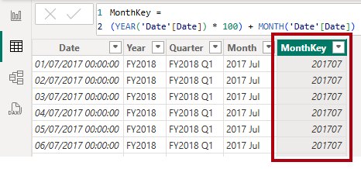
- Switch back to Report view.
- In the Data pane, select the Month field.
- On the Column Tools contextual ribbon, from inside the Sort group, select Sort by Column, and then select MonthKey.
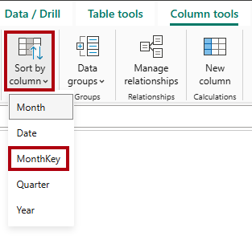
- In the matrix visual, notice that the months are now chronologically sorted.
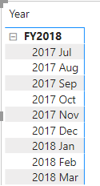

Complete the Date table
In this task, you’ll complete the design of the Date table by hiding a column and creating a hierarchy. You’ll then create relationships to the Sales and Targets tables.
- Switch to Model view.
- In the Date table, hide the MonthKey column (set Is Hidden to Yes).
- In the Data pane, select the Date table, right-click the Year column, and the select Create hierarchy.
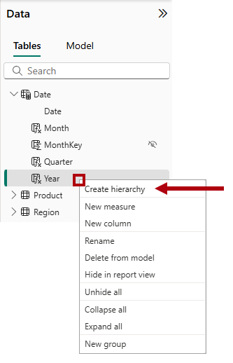
- In the Properties pane, in the Name box, replace the value with Fiscal.
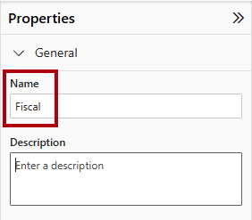
- Two add levels to the hierarchy, in the Hierarchy dropdown list, select Quarter and then select Month, and then select Apply Level Changes.
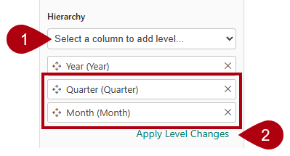
- Create the following two model relationships:
  - Date | Date to Sales | OrderDate
  - Date | Date to Targets | TargetMonth
- Hide the following two columns:
  - Sales | OrderDate
  - Targets | TargetMonth

Mark the Date table
In this task, you’ll mark the Date table as a date table.
- Switch to Report view.
- In the Data pane, select the Date table (not the Date field).
- On the Table Tools contextual ribbon, from inside the Calendars group, select Mark as Date Table.
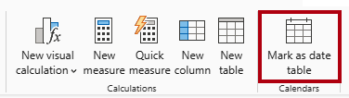
- In the Mark as a Date Table window, slide the Mark as a Date Table property to On.
- In the Choose a date column dropdown list, select Date.
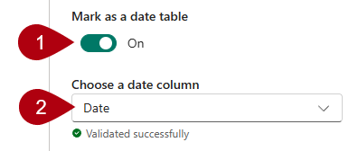
- Select Save.
- Save the Power BI Desktop file.

Create simple measures
In this task, you’ll create simple measures. Simple measures aggregate values in a single column or count rows of a table.
- In Report view, on Page 2, from the Data pane, drag the Sales | Unit Price field into the matrix visual.
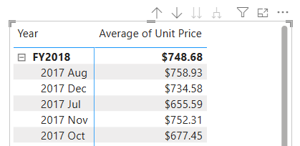
- In the visual fields pane (located in the Visualizations pane), in the Values well, notice that Unit Price field is configured as Average of Unit Price.
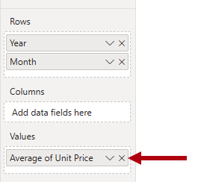
- Select the down-arrow for Average of Unit Price, and then notice the available menu options.
Visible numeric columns allow report authors at report design time to decide how column values will summarize (or not). However, it can result in inappropriate reporting.
Some data modelers don’t like leaving things to chance, so they choose to hide these columns and instead expose aggregation logic defined in measures. It’s the approach you’ll now take in this lab.
- To create a measure, in the Data pane, right-click the Sales table, and then select New Measure.
- In the formula bar, add the following measure definition:
code
Avg Price =
AVERAGE(Sales[Unit Price])
- Add the Avg Price measure to the matrix visual, and notice that it produces the same result as the Unit Price column (but with different formatting).
- In the Values well, open the context menu for the Avg Price field, and notice that it isn’t possible to change the aggregation technique.
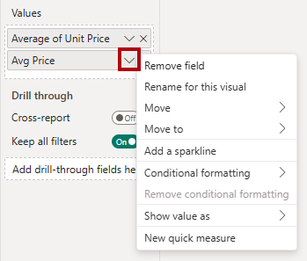
It’s not possible to modify the aggregation behavior of a measure.
- Use the snippets file definitions to create the following five measures for the Sales table:
  - Median Price
  - Min Price
  - Max Price
  - Orders
  - Order Lines
- Switch to Model view, and then multi-select the four price measures: Avg Price, Max Price, Median Price, and Min Price.
- For the multi-selection of measures, configure the following requirements:
  - Set the format to two decimal places.
  - Assign to a display folder named Pricing (use the Display folder property in the Properties pane).
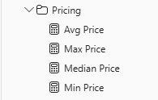
- Hide the Unit Price column.
- Multi-select the Order Lines and Orders measures, and then configure the following requirements:
  - Set the format use the thousands separator.
  - Assign to a display folder named Counts.
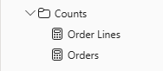
- In Report view, in the Values well of the matrix visual, for Average of Unit Price, select X to remove it.
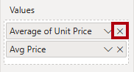
- Increase the size of the matrix visual to fill the page width and height.
- Add the following five measures to the matrix visual:
  - Median Price
  - Min Price
  - Max Price
  - Orders
  - Order Lines
- Verify that the results look sensible and are correctly formatted.
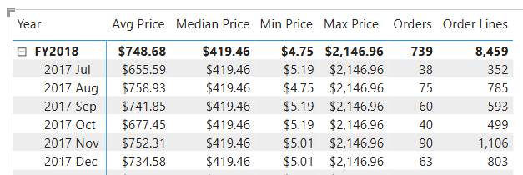

Create additional measures
In this task, you’ll create more measures that use more complex formulas.
- In Report view, select Page 1 and review the table visual of salespeople (on the right), noticing the total for the Sum of Target column.
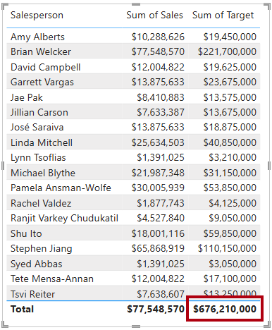
- Select the table visual, and then in the Visualizations pane, remove Sum of Target.
- Rename the Targets | Target column as TargetAmount.
- Create the following measure on the Targets table:
Target =
IF(
HASONEVALUE('Salesperson (Performance)'[Salesperson]),
SUM(Targets[TargetAmount])
)
- Format the Target measure for zero decimal places.
- Hide the TargetAmount column.
- Notice that the Targets table now appears at the top of the list.
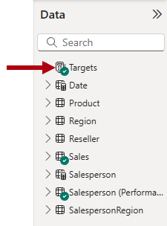
- Add the Target measure to the table visual.
- Notice that the Target column total is now BLANK.
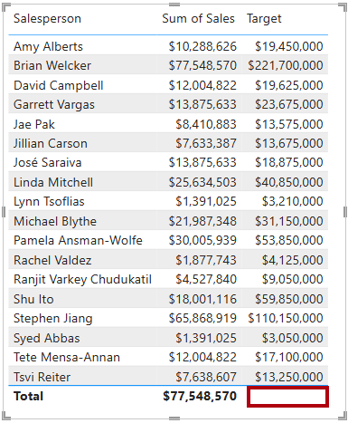
- Use the snippets file definitions to create the following two measures for the Targets table:
  - Variance
  - Variance Margin
- Format the Variance measure for zero decimal places.
- Format the Variance Margin measure as percentage with two decimal places.
- Add the Variance and Variance Margin measures to the table visual.
- Resize the table visual so all columns and rows can be seen.
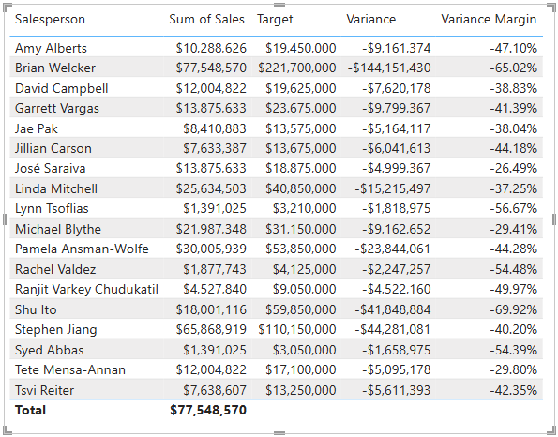
- Save the Power BI Desktop file.

